Magnet resonance imaging for horses - MRI

MRI (magnetic resonance imaging) is a diagnostic imaging technique that uses a strong magnetic field to produce two and three dimensional multilayer images of different bodyparts on three different levels (sagittal, transverse and dorsal).

MRI is a relatively new method in equine medicine, the first machines were installed in more prominent equine clinics in North-America and Europe a bit more than ten years ago. In 2010 a low-field Vet MR Geande magnet from Esaote was installed at the Agricultural University in Tartu, Estonia. For two years the magnet was mainly used on the University´s small animal patients but now it is finally ready to scan horses as well. The nearest MRI units in the area are in Sweden and Germany.

The biggest advantage of MRI compared to standard methods like radiography and ultrasound is that it acquires multiple slides of high anatomic detail and that various tissues (bones, ligaments etc.) can be imaged simultaneously. Therefore, with this new method
it is much easier to characterize lesions, their dimensions and localize them more accurately.

Another big advantage of MRI is that it does not use ionising radiation so it is completely safe for the patient and people involved.

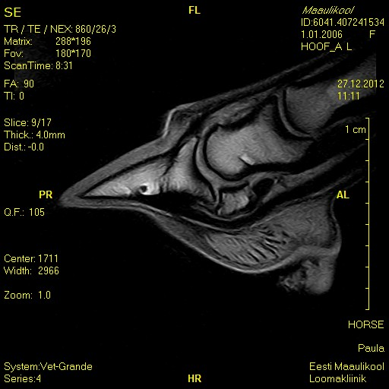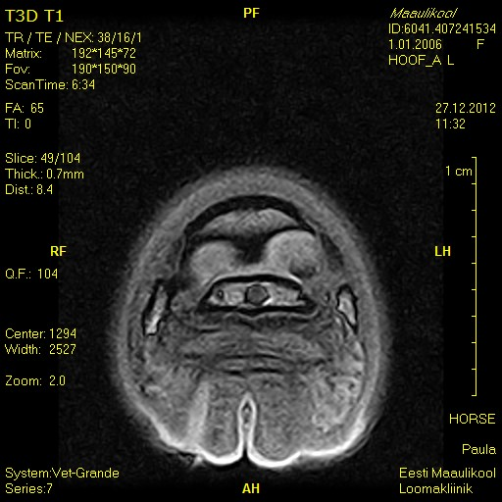
MRT pildid kabjast, sagitaal ja transversaal vaade

Indications for MRI

Before any MRI procedure the area to be scanned has to be narrowed down as much as possible. A thorough lameness exam (usually using nerv blocks) is inevitable to reduce the time of scanning and thus the general anaesthesia.
Depending on the patients size all areas of the lower leg including the carpus and tarsus as well as the head and sinuses can be scanned.
One of the most useful indications for MRI are diseases originating from the hoof. Largely due to the advances of MRI the complex disease formely know as navicular disease has been replaced with the term distal foot syndrom which characterizes various injuries of the ligaments, tendons and bones of the navicular apparatus. MRI is irreplaceble in diagnosing bone diseases that could not be detected earlier. The intensive scientific research going on worldwide has widened the possible list of diagnosises based on MRI as well as our understanding of various diseases of the lower leg.

Scan procedure

For the MRI scan the horse needs to be under general anaesthesia, only then the high quality of the images can be guaranteed. The horses have to arrive to the university clinic a day before the scan. This will enable our anaesthisiologist Heli Säre (DVM, PhD, Cert.VA) to examine the horses beforehand to minimize the risks of anaesthisia.

Prior to the MRI the horses shoes have to be removed. The whole procedure takes about 1.1,5h, depending on the size of the area scanned. The scan is carried out by veterinarians Triin Tohver and Reet Herm. The scans are evaluated by Dr.Alexia McKnight (DVM, DACVR) and by Triin Tohver. To complete the final report with the results takes about 48h .

For any questions please feel free to contact the Agricultural Universitys Large Animal Clinic ( +372 731 3713 ) or Triin Tohver ( +372 518 6416 ).

